**Strategy recommendation for increasing number of customers for TS restaurants based on analysis of seasonal effect on the business.**

**Brief Introduction:**

We hereby propose to perform our analysis on the customer reviews in the YELP dataset, of TS restaurants, into two sets:

1. Summer customer reviews
2. Non-Summer customer reviews

Looking at the results of the preliminary exploratory data analysis on the dataset, we find that the number of customers increase during the summer and decrease during rest of the year.

Hence, we came up with a model to analyze the reviews into two sets, the first set being the customer reviews that the restaurant receives during the summer season, that is when the customers increase drastically and the second set being the months that are not included in the first set.

**Methodology:**

We will consider April, May, June and July as the summer months whereas the second set of months will be January, February, March, August, September, October, November and December.

The first step after bifurcating the reviews into two sets, would be to perform topic modelling on these sets. A word cloud as a result of this process will depict the most discussed topics in each set, which will give us a clear idea of the restaurant performance for each set. As we want to build our strategy recommendation for the restaurant to increase the business, we are only interested in the negative reviews received by the restaurant, hence this will narrow down our focus to problems faced by the visiting customers.

After we form the word clouds, there will be a few topics that are common in both the sets, which regardless of the season, are problems faced by customers due to restaurant inefficiency. Our first part of the strategy will be based on the common problems and what improvements can be incorporated by the restaurant for those problems. Our primary goal of this research would be to find the unique problems in each set of months.

Once we have those issues represented by our word clouds, we will address each issue and give a detailed research for each of the TS restaurants. Our research will give the restaurant a clear idea of the factors which when combined with the season makes the customer experience unsatisfactory. After we have all the issues on hand, we will prove the unpleasant customer experience with the statistics and trends for the past 10 years of the restaurant.

Then, with the help of some domain knowledge and our research on the competitor restaurants’ performance for the same issues, we can develop strategies that will help the restaurant to increase customer satisfaction and helps in customer retention. A boost in the customer experience when combined with innovative marketing strategies will help the restaurant to attract new customers which in turn aids business growth.

**Flow chart of the project process:**

**NOT SUMMERTIME**

Aug, Sep, Oct, Nov, Dec, Jan, Feb, March

**SUMMERTIME**

April, May, June, July

**Performing Topic Modelling**

**If we can find the negative topics for the above two seasons then we can recommend the solutions to overcome that negative topic, so that customers satisfaction increases eventually business increases**

**Ex: Food, Service, Managment**

**Topics: D, E, F, G, H, I**

**Most Discussed Topics**

**Performing Topic Modelling**

**Topics: A, B, C, D, E, F**

**Reviews (only at non-summer)**

**Reviews (only at summertime)**

**Negative Topics for summer**

**Positive Topics for non-summers**

**Negative Topics for non-summers**

**Positive Topics for summer**

**Unique Topics for Non-Summer: G, H, I**

**Unique Topics for summer: A, B, C**

**Common Topics: D, E, F**

**Most Discussed Topics**

**Only on TS Restaurants**

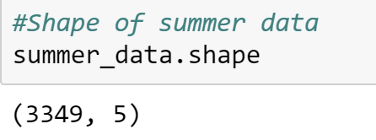

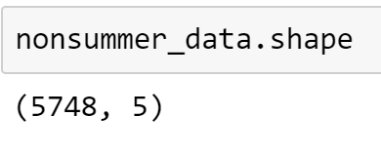

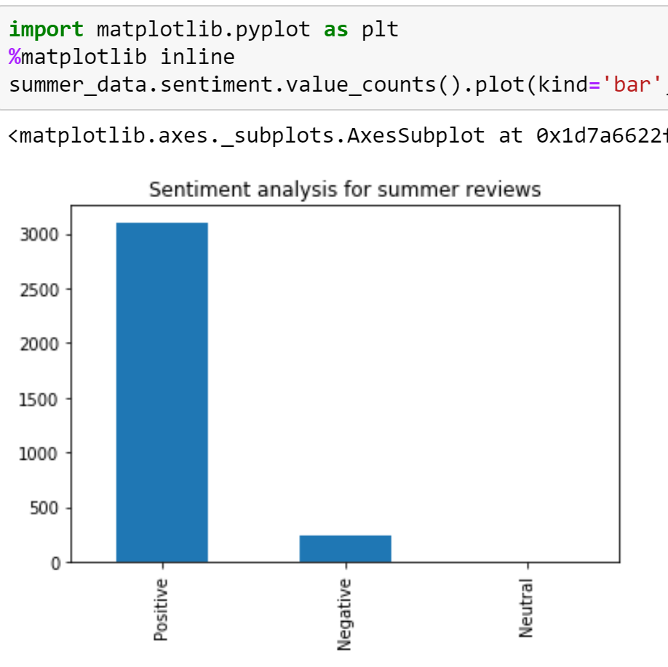

**Word Cloud on Negative Reviews**

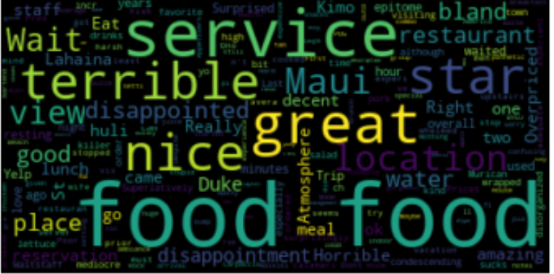

**Topic Modeling on summer data using LDA**

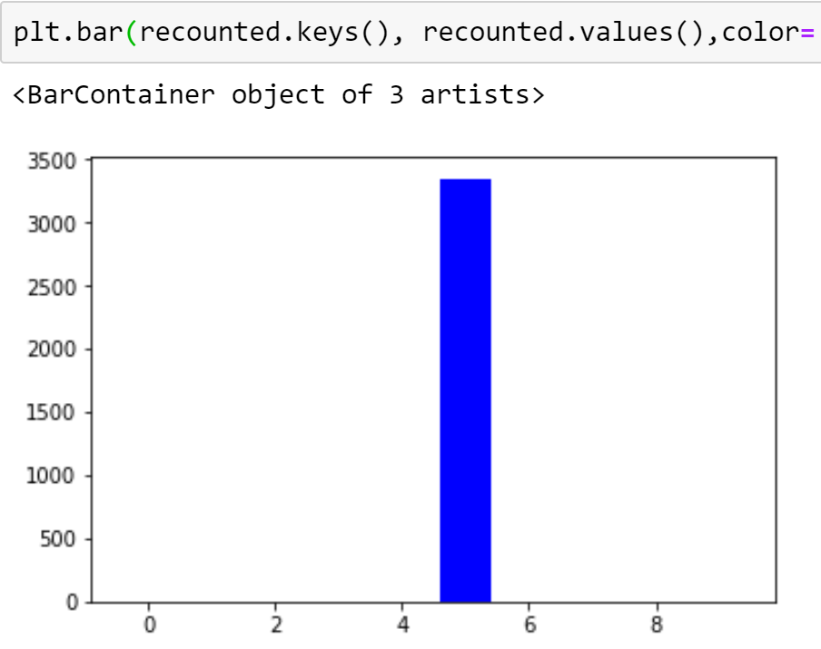

Topic #5: great food good fish service view place hula maui dinner amazing drinks pie just delicious

# Non-negative Matrix Factorization(NMF) on Summer Reviews

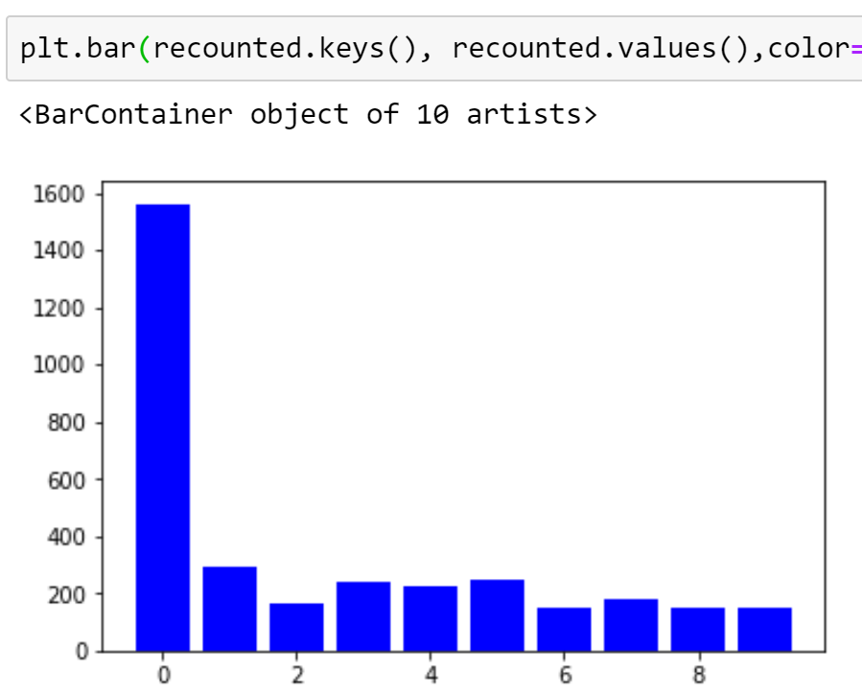

Topic #0: good food just really dinner ordered maui nice time got

# LDA NON SUMMER Data

# 

Topic #8:

great food good fish servic view place drink hula maui

# Non-negative Matrix Factorization(NMF) on Non Summer Reviews

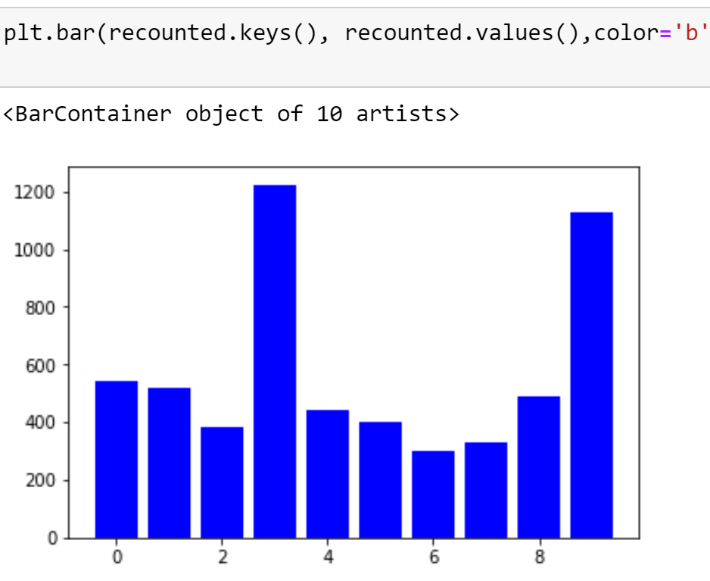

Topic #3:order fish delici salad shrimp fresh sauc dinner coconut rib

Topic #9:wait tabl reserv bar menu restaur seat time minut ask

# TOPIC MODELING ONLY ON NOUNS

**VADER(Sentiment Intensity Analyzer) for sentiments**

**Only on TS Restaurants**

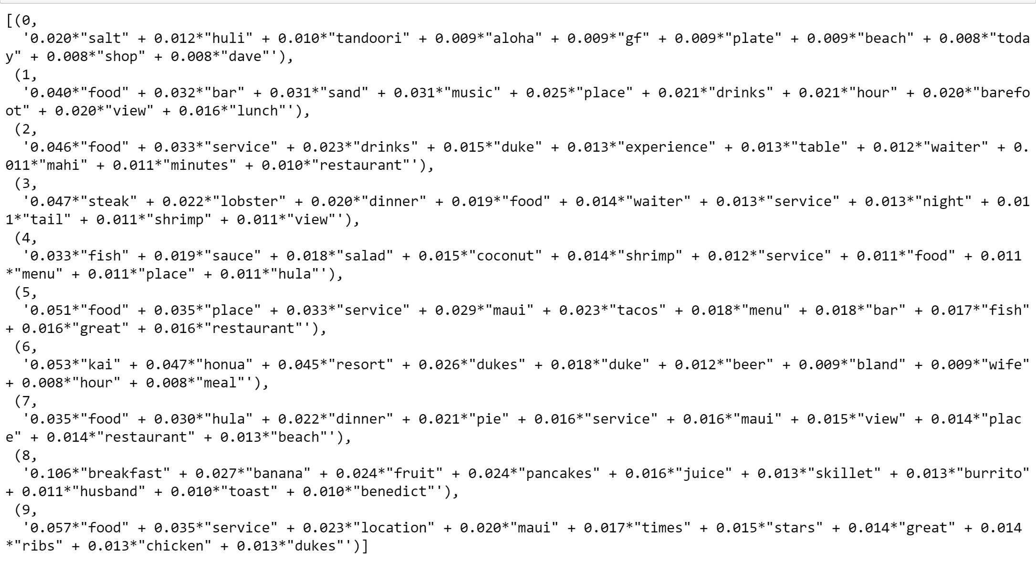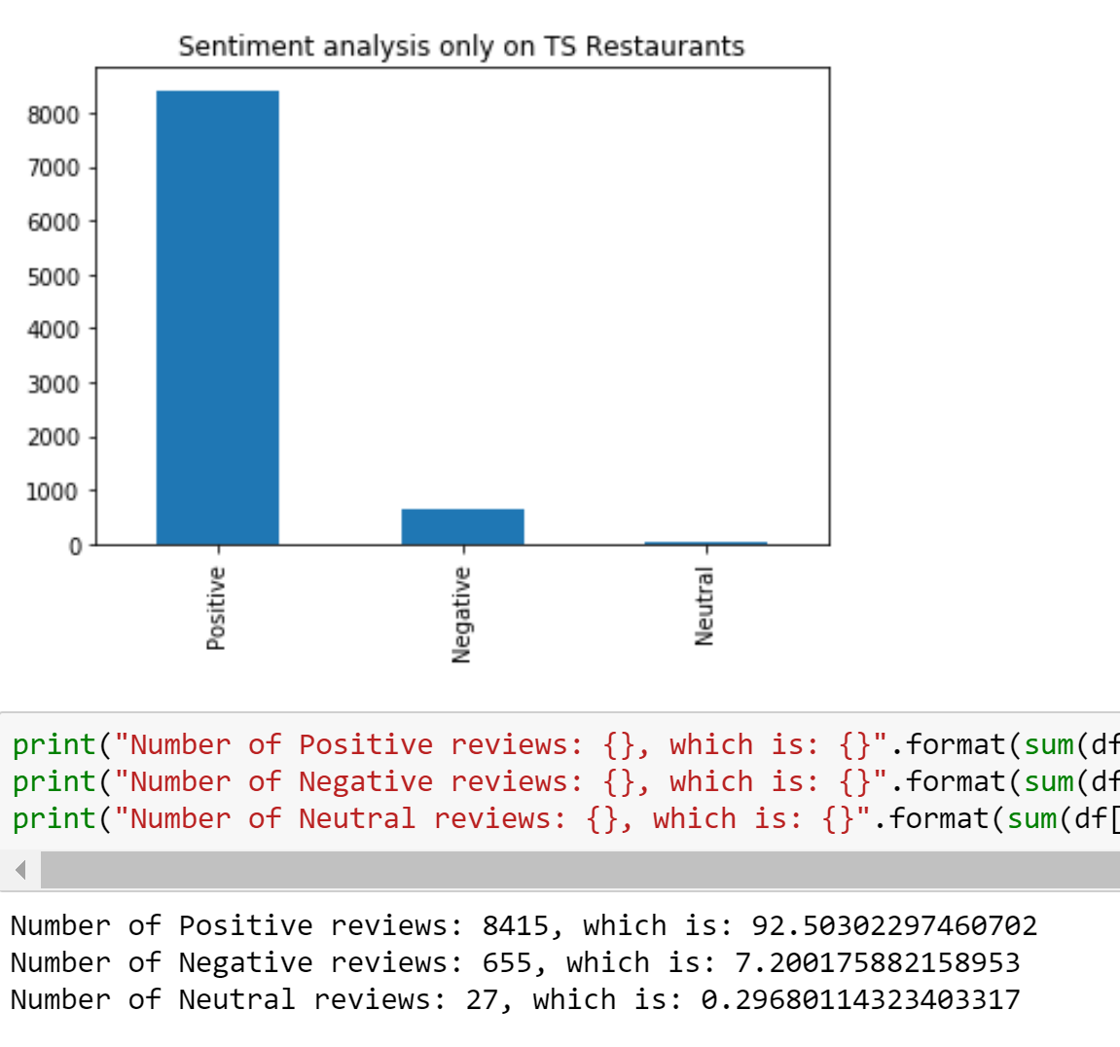

**Sentimental Count on Non TS Restaurants**

